DEPARTMENT OF COMPUTER TECHNOLOGY
SKILL-2 B.Sc. CT : NETWORK LAB
IV SEMESTER
PROGRAMME OUTCOME
- The Programme exhibits solid fundamental knowledge in mathematics, computer science with a breadth of inter-disciplinary knowledge.
- Ability for independent thinking, possesses problem-solving skills, and excels in the capability for self-learning to allow for life-long learning.
- Capability to apply design and development principles in the construction of software systems of varying complexity.
- Developing leadership qualities, and good communication, teamwork, social, and professional skills.
- An ability to design, implement and evaluate a computational system to meet desired needs within realistic constraints.
- An ability to use appropriate techniques, skills, and tools necessary for computing practice.
- Recognition of the need for and an ability to engage in continuing professional development
- Ability to apply knowledge of computing, mathematics and business accounting principles appropriate to the discipline.
- Students will be able to communicate effectively in a variety of professional contexts
- Identify, formulate, and solve computer science problems (problem formulation)

Course Objectives

- To understand the Modes of data transmission
- To understand the Transmission Errors: Detection and correction
- To understand the various routing algorithms.
- To know the concept of data transfer between nodes
- To know the concept of inter process communication technique that is
used for client-server based applications

List of Experiments
1. Write a program to Detect Errors using Vertical Redundancy Check (VRC).
2. Write a program to Detect Errors using Longitudinal Redundancy Check (LRC).
3. Write a program to Detect Errors using Cyclic Redundancy Check (CRC).
4. Write a Socket program to implement Asynchronous Communication.
5. Write a Socket program to implement Isochronous Communication.
6. Write a program to implement Stop & Wait Protocol.
7. Write a program to implement Sliding Window Protocol.
8. Write a program to implement the Shortest Path Routing using Dijkstra algorithm.
9. Write a Socket Program to Perform file transfer from Server to the Client.
10. Write a Program to implement Remote Procedure call under Client / Server Environment
Prerequisite
Knowledge about simple networking concepts
Software requirement
- Turbo C
- Java- JDK
Course Outcome
After completing the course, students will be able to:
- Understand the structure and organization of computer networks
- Understand the error detection and correction mechanism
- Understand the concept of routing algorithms in networks
- Understand the concept of different communication modes
- Understand the concept of file transfer between client and server
- Understand the concept of Remote process communication

Introduction to Socket Programming and methods used in Socket

Socket Programming
Sockets provide the communication mechanism between two computers using TCP. A client program creates a socket on its end of the communication and attempts to connect that socket to a server.
When the connection is made, the server creates a socket object on its end of the communication. The client and the server can now communicate by writing to and reading from the socket.
The java.net.Socket class represents a socket, and the java.net.ServerSocket class provides a mechanism for the server program to listen for clients and establish connections with them.
The following steps occur when establishing a TCP connection between two computers using sockets −
- The server instantiates a ServerSocket object, denoting which port number communication is to occur on.
- The server invokes the accept() method of the ServerSocket class. This method waits until a client connects to the server on the given port.
- After the server is waiting, a client instantiates a Socket object, specifying the server name and the port number to connect to.
- The constructor of the Socket class attempts to connect the client to the specified server and the port number. If communication is established, the client now has a Socket object capable of communicating with the server.
- On the server side, the accept() method returns a reference to a new socket on the server that is connected to the client's socket.
After the connections are established, communication can occur using I/O streams. Each socket has both an OutputStream and an InputStream. The client's OutputStream is connected to the server's InputStream, and the client's InputStream is connected to the server's OutputStream.
TCP is a two-way communication protocol, hence data can be sent across both streams at the same time. Following are the useful classes providing complete set of methods to implement sockets.

ServerSocket Class Methods
The java.net.ServerSocket class is used by server applications to obtain a port and listen for client requests.

The ServerSocket class has four constructors −
S.No. | Method & Description
1 | public ServerSocket(int port) throws IOException  Attempts to create a server socket bound to the specified port. An exception occurs if the port is already bound by another application.
2 | public ServerSocket(int port, int backlog) throws IOException  Similar to the previous constructor, the backlog parameter specifies how many incoming clients to store in a wait queue.
3 | public ServerSocket(int port, int backlog, InetAddress address) throws IOException  Similar to the previous constructor, the InetAddress parameter specifies the local IP address to bind to. The InetAddress is used for servers that may have multiple IP addresses, allowing the server to specify which of its IP addresses to accept client requests on.
4 | public ServerSocket() throws IOException  Creates an unbound server socket. When using this constructor, use the bind() method when you are ready to bind the server socket.
If the ServerSocket constructor does not throw an exception, it means that your application has successfully bound to the specified port and is ready for client requests.
Following are some of the common methods of the ServerSocket class −
Sr.No. | Method & Description
1 | public int getLocalPort()  Returns the port that the server socket is listening on. This method is useful if you passed in 0 as the port number in a constructor and let the server find a port for you.
2 | public void bind(SocketAddress host, int backlog)  Binds the socket to the specified server and port in the SocketAddress object. Use this method if you have instantiated the ServerSocket using the no-argument constructor.

When the ServerSocket invokes accept(), the method does not return until a client connects. After a client does connect, the ServerSocket creates a new Socket on an unspecified port and returns a reference to this new Socket. A TCP connection now exists between the client and the server, and communication can begin.

Socket Class Methods
The java.net.Socket class represents the socket that both the client and the server use to communicate with each other. The client obtains a Socket object by instantiating one, whereas the server obtains a Socket object from the return value of the accept() method.
The Socket class has five constructors that a client uses to connect to a server −
Sr.No. | Method & Description
1 | public Socket(String host, int port) throws UnknownHostException, IOException.  This method attempts to connect to the specified server at the specified port. If this constructor does not throw an exception, the connection is successful and the client is connected to the server.
2 | public Socket(InetAddress host, int port) throws IOException  This method is identical to the previous constructor, except that the host is denoted by an InetAddress object.
3 | public Socket(String host, int port, InetAddress localAddress, int localPort) throws IOException.  Connects to the specified host and port, creating a socket on the local host at the specified address and port.
When the Socket constructor returns, it does not simply instantiate a Socket object but it actually attempts to connect to the specified server and port.
Some methods of interest in the Socket class are listed here. Notice that both the client and the server have a Socket object, so these methods can be invoked by both the client and the server.

Sr.No. | Method & Description
1 | public void connect(SocketAddress host, int timeout) throws IOException  This method connects the socket to the specified host. This method is needed only when you instantiate the Socket using the no-argument constructor.
2 | public InetAddress getInetAddress()  This method returns the address of the other computer that this socket is connected to.
3 | public int getPort()  Returns the port the socket is bound to on the remote machine.
4 | public int getLocalPort()  Returns the port the socket is bound to on the local machine.
5 | public SocketAddress getRemoteSocketAddress()  Returns the address of the remote socket.
6 | public InputStream getInputStream() throws IOException  Returns the input stream of the socket. The input stream is connected to the output stream of the remote socket.
7 | public OutputStream getOutputStream() throws IOException  Returns the output stream of the socket. The output stream is connected to the input stream of the remote socket.
8 | public void close() throws IOException  Closes the socket, which makes this Socket object no longer capable of connecting again to any server.

InetAddress Class Methods
This class represents an Internet Protocol (IP) address. Here are following usefull methods which you would need while doing socket programming −
Sr.No. | Method & Description
1 | static InetAddress getByAddress(byte[] addr)  Returns an InetAddress object given the raw IP address.
2 | static InetAddress getByAddress(String host, byte[] addr)  Creates an InetAddress based on the provided host name and IP address.
3 | static InetAddress getByName(String host)  Determines the IP address of a host, given the host's name.
4 | String getHostAddress()  Returns the IP address string in textual presentation.
5 | String getHostName()  Gets the host name for this IP address.
6 | static InetAddress InetAddress getLocalHost()  Returns the local host.
7 | String toString()  Converts this IP address to a String.

Ex No: 01 Program To Detect Errors Using Vertical Redundancy Check (VRC)

AIM:
Write a Program to Detect Errors Using Vertical Redundancy Check (VRC)

VRC
Vertical redundancy check (VRC) is an error-checking method used on an eight-bit ASCII character. In VRC, a parity bit is attached to each byte of data, which is then tested to determine whether the transmission is correct. VRC is considered an unreliable error-detection method because it only works if an even number of bits is distorted.

Procedure to run a program

Step 1: Locate the TC.exe file and open it. You will find it at location C:\TC\BIN\.
Step 2: File > New (as shown in above picture) and then write your C program
Step 3: Save the program using F2 (OR file > Save), the extension should be “.c”.
Step 4: Compile the program using Alt + F9 OR Compile > Compile
Step 5: Press Ctrl + F9 to Run (or select Run > Run in menu bar ) the C program.
Step 6: Alt+F5 to view the output of the program at the output screen.

SOURCE CODE:
#include<stdio.h> //Header files
#include<conio.h>
int binary(int); //function for binary calculation
void parity(int[]); //function for parity calculation
int arr[9], arr1[9];
char chr;
int temp,temp1,i;
void main()
{
char chr1;
clrscr(); //function to be used to clear the screen
printf("Enter Data:"); //Enter the data to be transfered
scanf("%c%c", &chr,&chr1);
temp=chr;
binary(temp);
printf("\n ASCII value is:%d \n ",temp);
printf("\n Binary form:");
for(i=0;i<8;i++)
{
arr1[i]=arr[i];
printf("%d", arr[i]);
}
printf("\n");
parity(arr);
temp1=chr1;
binary(temp1);
printf("\n \n ASCII value is:%d\n", temp1);

printf("\n Binary form:");
for(i=0;i<8;i++)
{
printf("%d", arr[i]);
}
parity(arr);
getch(); //function for getting a character
}
void parity(int a[]) //function implementation for parity calculation
{
int count;
count=0;
for(i=0;i<8;i++)
{
if(a[i]==1)
count++;
}
if(count%2==0)
a[8]=0;
else
a[8]=1;
count=0;
printf("\n Receiver side:\n");
printf("\n \n VRC:\n");
for(i=0;i<9;i++)
{
if(i==8)

printf("|");
printf("%d", a[i]);
}
}
int binary(int x) //function implementation for binary calculation
{
int rem;
int ctr=0;i=1;
do
{
rem=x%2;
arr[i]=rem;
if(rem==1)
{
ctr++;
}
x=x/2;
i++;
} while(x!=0);
if(ctr%2==0)
{
arr[0]=0;
}
else
{
arr[0]=1;
}
return(0);
}

OUTPUT:
Enter Characters:sa

ASCII value is:115

Binary form:11100111

Receiver side:

VRC:
11100111|0

ASCII value is:97
Binary form:11000011

Reciever side:

VRC:
11000011|0

Ex No:02 Program to Detect Errors using Longitudinal Redundancy Check(LRC)

AIM:
Write a Program to Detect Errors using Longitudinal Redundancy Check(LRC).
LRC
A longitudinal redundancy check (LRC) is an error-detection method for determining the correctness of transmitted and stored data. LRC verifies the accuracy of stored and transmitted data using parity bits. This term is also known as a horizontal redundancy check.

Procedure to run a program

Step 1: Locate the TC.exe file and open it. You will find it at location C:\TC\BIN\.
Step 2: File > New (as shown in above picture) and then write your C program
Step 3: Save the program using F2 (OR file > Save), the extension should be “.c”.
Step 4: Compile the program using Alt + F9 OR Compile > Compile
Step 5: Press Ctrl + F9 to Run (or select Run > Run in menu bar ) the C program.
Step 6: Alt+F5 to view the output of the program at the output screen.

SOURCE CODE:
#include<stdio.h> //Header files
#include<conio.h>
int binary(int); //function for binary calculation
void parity(int[],int[]); //function for parity calculation
int arr[8],arr1[8],parityarr[8];
char chr;
int temp,temp1,i;
void main()
{
char chr1;
clrscr();
printf("Enter a character:");
scanf("%c%c", &chr,&chr1); //Enter the data to be transferred
temp=chr;
binary(temp);
printf("\n\n ASCII value is:%d",temp);
printf("\n BIinary form:");
for(i=7;i>=0;i--)
{
arr1[i]=arr[i];
printf("%d",arr[i]);
}
printf("\n");
temp1=chr1;
binary(temp1);

printf("\n ASCII value is:%d\n",temp1);
printf("\n Binary form:");
for(i=7;i>=0;i--)
{
printf("%d", arr[i]);
}
parity(arr,arr1);
for(i=7;i>=0;i--)
{
arr[i]=0;
arr1[i]=0;
}
getch();
}
void parity(int arr[],int arr1[]) //function for parity calculation
{
printf("\n Receiver side:\n");
printf("\n\n LRC:\n");
for(i=7;i>=0;i--)
{
printf("%d", arr[i]);
}
printf("\n");
for(i=7;i>=0;i--)
{

printf("%d", arr1[i]);
}
printf("\n-------------\n");
for(i=0;i<8;i++)
{
if(arr[i]==0 && arr1[i]==0 || arr[i]==1 && arr1[i]==1)
{
parityarr[i]=0;
}
else if(arr[i]==0 && arr1[i]==1 || arr[i]==1 && arr1[i]==0)
{
parityarr[i]=1;
}
}
for(i=7;i>=0;i--)
{
printf("%d", parityarr[i]);
}
}
int binary(int x) //function for binary calculation
{
int rem;
int ctr=0,i=1;
do
{
rem=x%2;
arr[i]=rem;

if(rem==1)
{
ctr++;
}
x=x/2;
i++;
} while(x!=0);
if(ctr%2==0)
{
arr[0]=0;
}
else
{
arr[0]=1;
}
return 0;
}

OUTPUT:

Enter Characters:sa

ASCII value is:115
BIinary form:11100111

ASCII value is:97
Binary form:11000011

Receiver side:

LRC:
11000011
11100111
-------------
00100100

Ex No :03 Program To Detect Errors Using Cyclic Redundancy Check (CRC).

AIM:
Write a Program To Detect Errors Using Cyclic Redundancy Check (CRC).
CRC
A cyclic redundancy check (CRC) is an error-detecting code commonly used in digital networks and storage devices to detect accidental changes to raw data. Blocks of data entering these systems get a short check value attached, based on the remainder of a polynomial division of their contents.
Procedure to run a program

Step 1: Locate the TC.exe file and open it. You will find it at location C:\TC\BIN\.
Step 2: File > New (as shown in above picture) and then write your C program
Step 3: Save the program using F2 (OR file > Save), the extension should be “.c”.
Step 4: Compile the program using Alt + F9 OR Compile > Compile
Step 5: Press Ctrl + F9 to Run (or select Run > Run in menu bar ) the C program.
Step 6: Alt+F5 to view the output of the program at the output screen.

SOURCE CODE:
#include<stdio.h>
#include<string.h>
int divrlen, divlen,i,j;
char divisor[100],div[100],divcp[100];
int main()
{
clrscr();
printf("Enter divisor:");
scanf("%s", divisor); //Enterv the divisor value
printf("\n Enter dividend:");
scanf("%s",div); //Enter the dividend value
divrlen=strlen(divisor);
divlen=strlen(div);
strcpy(divcp,div); //Function used to copy two strings
for(i=0;i<divrlen-1;i++)
{
div[divlen+i]='0';
}
div[divlen+i]='\0';
divlen=strlen(div); //Function used to calculate the length of the string
i=0;
while(1)
{
if(div[i]=='0')
i++;
else if(divlen-i>=divrlen)

{
for(j=0;j<divrlen;j++)
{
div[i++]=(div[i]==divisor[j])?'0':'1'; //Conditional opertor
}
i=i-divrlen;
}
else
break;
}
printf("\n Remainder=%s\n\n", div);
printf("Data sent=%s", divcp);
for(i=divlen-divrlen+1;i<divlen;i++)
{
printf("%c",div[i]);
}
return(0);
}

OUTPUT :
Enter divisor:1101

Enter dividend:110010101

Remainder=000000000101

Data sent=110010101101

Ex No : 04 Socket Program To Implement Asynchronous Communication

AIM:
Write a Socket Program to Implement Asynchronous Communication
Asynchronous transmission
It is the transmission of data in which each character is a self-contained unit with its own start and stop bits and an uneven interval between them. Asynchronous transmission is also referred to as start/stop transmission.

Procedure to run a Program
Step 1:Write a server and client programs on the notepad and save it with .java extension,
Step 2: Open two different Command Prompt.
Step 3:Set the directory in which the .java file is saved.
Step 4:Use the following command to compile the Java programs. It generates a .class file in the same folder. It also shows an error if any.
Javac filename.java
Step 5:Use the following command to run the Java program: java Filename, First execute the server program and then execute the client program and type the message in client side.

SOURCE CODE:
Server:
import java.net.*; //java Network package
import java.io.*;
class MyServer
{
public static void main(String args[])throws Exception
{
ServerSocket ss=new ServerSocket(3333); //Creation of socket
Socket s=ss.accept();
DataInputStream din=new DataInputStream(s.getInputStream());
DataOutputStream dout=new DataOutputStream(s.getOutputStream());
BufferedReader br=new BufferedReader(new InputStreamReader(System.in));
String str=" ",str2=" ";
while(!str.equals("stop"))
{
str=din.readUTF(); //method reads in a string that has been encoded using
//modified UTF-8 format.
System.out.println("client says:"+str);
str2=br.readLine();
dout.writeUTF(str2);
dout.flush(); //flush() method flushes the stream.
}
din.close(); //close all the connections
s.close();
ss.close();
}
}

Client:
import java.net.*;
import java.io.*;
public class MyClient
{
public static void main(String args[])throws Exception //main function
{
Socket s=new Socket("localhost",3333);
DataInputStream din=new DataInputStream(s.getInputStream());
//It is used to read the number of bytes from the input stream.
DataOutputStream dout=new DataOutputStream(s.getOutputStream());
//It is used to return the number of bytes written to the data output stream
BufferedReader br=new BufferedReader(new
InputStreamReader(System.in));
String str=" ",str2=" ";
while(!str.equals("stop"))
{
str=br.readLine();
//It is used to provide a formatted prompt, then reads a single line of text from the console.
dout.writeUTF(str);
// writes a string to the underlying output stream using modified UTF-8 encoding.
dout.flush();
str2=din.readUTF();
//reads in a string that has been encoded using a modified UTF-8 format
System.out.println("Server says:"+str2);
}
dout.close();
s.close();
}

OUTPUT:

Server:
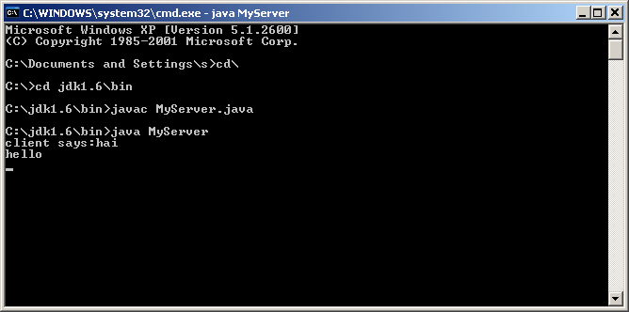

Client:
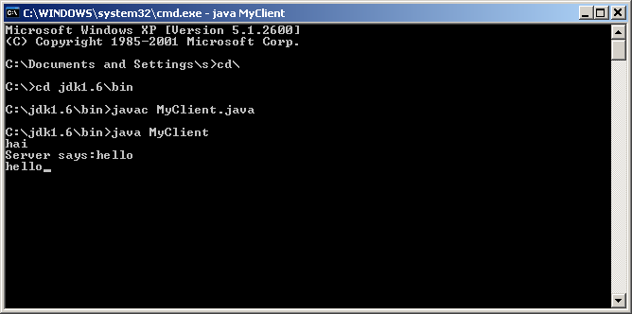

Ex No :05 Socket Program To Implement Isochronous Communication.

AIM:
Write a Socket Program To Implement Isochronous Communication.
Isochronous Communication
An isochronous data transfer system combines the features of an asynchronous and synchronous data transfer system. An isochronous data transfer system sends blocks of data asynchronously, in other words the data stream can be transferred at random intervals. Each transmission begins with a start packet.
Procedure to run a Program
Step 1:Write a server and client programs on the notepad and save it with .java extension,
Step 2: Open two different Command Prompt.
Step 3:Set the directory in which the .java file is saved.
Step 4:Use the following command to compile the Java programs. It generates a .class file in the same folder. It also shows an error if any.
Javac filename.java
Step 5:Use the following command to run the Java program: java Filename, First execute the server program and then execute the client program and type the message in client side.

SOURCE CODE:
Server:
import java.net.*;
import java.io.*;
public class tcpechoserver
{
public static void main(String[] args) throws IOException
{
ServerSocket sock=null;
BufferedReader fromClient=null;
OutputStreamWriter toClient=null;
Socket Client=null;
try
{
sock=new ServerSocket(4000);
System.out.println("Server Ready");
Client=sock.accept(); //The accept() method of ServerSocket class is used to accept the incoming request to the socket.
System.out.println("Client Connected:");
fromClient=new BufferedReader(new InputStreamReader(Client.getInputStream()));
//It reads bytes and decodes them into characters using a specified charset.
toClient=new OutputStreamWriter(Client.getOutputStream());
//It creates an OutputStreamWriter that uses the default character encoding.
String line;
while(true)
{
line=fromClient.readLine();
if((line==null)||line.equals("bye"))
break;
System.out.println("Client["+line+"]");
toClient.write("Server["+line+"]\n");
toClient.flush();
}
fromClient.close();
toClient.close();
Client.close();
System.out.println("Client Disconnected");
}
catch(IOException ioe)
{
System.err.println(ioe);
}
}
}

Client:
import java.net.*;
import java.io.*;
public class tcpechoclient
{
public static void main(String args[]) throws IOException
{
BufferedReader fromServer=null,fromUser=null;
//BufferedReader is Java class to reads the text from an Input stream (like a file) by buffering //characters that seamlessly reads characters, arrays or lines.
PrintWriter toServer=null;
Socket sock=null;
try
{
if(args.length==0)
sock=new Socket(InetAddress.getLocalHost(),4000);
else
sock=new Socket(InetAddress.getByName(args[0]),4000);
fromServer=new BufferedReader(new InputStreamReader(sock.getInputStream()));
fromUser=new BufferedReader(new InputStreamReader(System.in));
toServer=new PrintWriter(sock.getOutputStream(),true);
//It is used to print the formatted representation of objects to the text-output stream.
String Usrmsg,Srvmsg;
System.out.println("Type\"bye\" to quit");
while(true)
{
System.out.println("Enter message to server:");
Usrmsg=fromUser.readLine();

if(Usrmsg==null || Usrmsg.equals("bye"))
{
toServer.println("bye");
break;
}
else
toServer.println(Usrmsg);
Srvmsg=fromServer.readLine();
System.out.println(Srvmsg);
}
fromUser.close();
fromServer.close();
toServer.close();
sock.close();
}
catch(IOException ioe)
{
System.err.println(ioe);
}
}
}

OUTPUT:

Server:
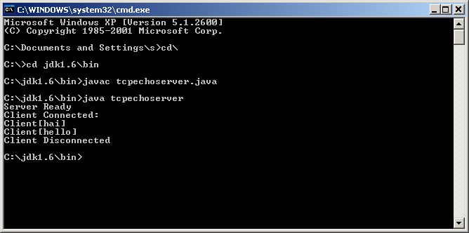

Client: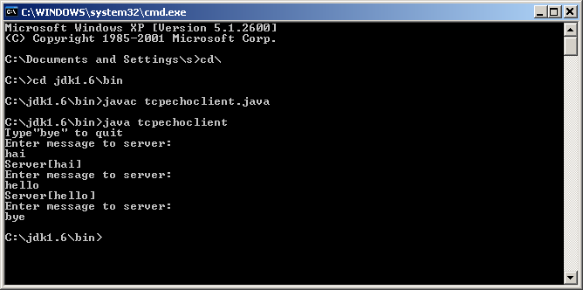

Ex No :06 Program To Implement Stop & Wait Protocol

AIM:
Write a program to Implement Stop & Wait Protocol
Stop & Wait Protocol
Stop and Wait Protocol is a flow control protocol where sender sends one data packet to the receiver and then stops and waits for its acknowledgement from the receiver.
Procedure to run a Program
Step 1:Write a server and client programs on the notepad and save it with .java extension,
Step 2: Open two different Command Prompt.
Step 3:Set the directory in which the .java file is saved.
Step 4:Use the following command to compile the Java programs. It generates a .class file in the same folder. It also shows an error if any.
Javac filename.java
Step 5:Use the following command to run the Java program: java Filename, First execute the server program and then execute the client program and type the message in client side.

SOURCE CODE
Sender:
import java.io.*;
import java.net.*;
public class Sender
{
Socket sender;
ObjectOutputStream out;
ObjectInputStream in;
String packet,ack,str,msg;
int n,i=0,sequence=0;
Sender(){}
public void run()
{
try
{
BufferedReader br=new BufferedReader(new InputStreamReader(System.in));
System.out.println("Waiting for connection....");
sender=new Socket("localhost",2004);
sequence=0;
out=new ObjectOutputStream(sender.getOutputStream());
out.flush();
in=new ObjectInputStream(sender.getInputStream());
str=(String)in.readObject();
System.out.println("Reciever >"+str);
System.out.println("Enter data to send....");
packet=br.readLine();
n=packet.length();

do
{
try
{
if(i<n)
{
msg=String.valueOf(sequence);
msg=msg.concat(packet.substring(i,i+1));
}
else if(i==n)
{
msg="end";out.writeObject(msg);break;
}
out.writeObject(msg);
sequence=(sequence==0)?1:0;
out.flush();
System.out.println("Data sent >"+msg);
ack=(String)in.readObject();
System.out.println("Waiting for ack....\n\n");
if(ack.equals(String.valueOf(sequence)))
{

i++;
System.out.println("Reciever >"+"packet recieved\n\n");
}
else
{
System.out.println("Time out resending data....\n\n");

sequence=(sequence==0)?1:0;

}
}
catch(Exception e){}
} while(i<n+1);
System.out.println("all data sent.exiting");
}
catch(Exception e){}
finally
{
try
{
in.close();
out.close();
sender.close();
}
catch(Exception e){}
}
}

public static void main(String args[])
{
Sender s=new Sender();
s.run();
}
}

Reciever:
import java.io.*;
import java.net.*;
public class Reciever
{
ServerSocket reciever;
Socket connection=null;
ObjectOutputStream out;
ObjectInputStream in;
String packet,ack,data=" ";
int i=0,sequence=0;
Reciever(){}
public void run()
{
try
{
BufferedReader br=new BufferedReader(new InputStreamReader(System.in));
reciever=new ServerSocket(2004,10);
System.out.println("Waiting for connection....");
connection=reciever.accept();
sequence=0;
System.out.println("Connection established:");
out=new ObjectOutputStream(connection.getOutputStream());
//Creates an ObjectOutputStream that writes to the specified OutputStream.
out.flush();
in=new ObjectInputStream(connection.getInputStream());
out.writeObject("Connected");
do
{
try

{
packet=(String)in.readObject();
if(Integer.valueOf(packet.substring(0,1))==sequence)
{
data+=packet.substring(1);
sequence=(sequence==0)?1:0;
System.out.println("\n\n Reciever >"+packet);
}
else
{
System.out.println("\n\n Reciever >"+packet+"duplicate data");
}
if(i<3)
{
out.writeObject(String.valueOf(sequence));
i++;
}
else
{
out.writeObject(String.valueOf((sequence+1)%2));
i=0;
}
}
catch(Exception e){}
}
while(!packet.equals("end"));

System.out.println("Data recieved="+data);
out.writeObject("Connection ended:");

}
catch(Exception e){}
finally
{
try
{
in.close();
out.close();
reciever.close();
}
catch(Exception e){}
}
}
public static void main(String args[])
{
Reciever s=new Reciever();
while(true)
{
s.run();
}}}

OUTPUT:

Sender: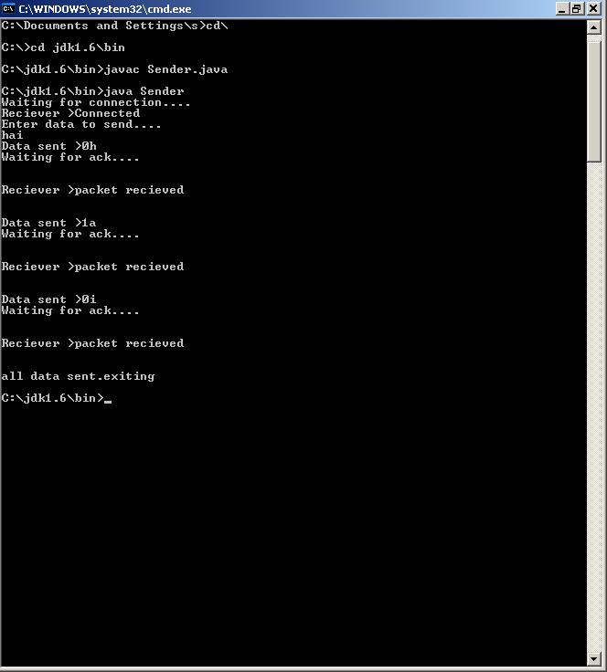

Receiver:

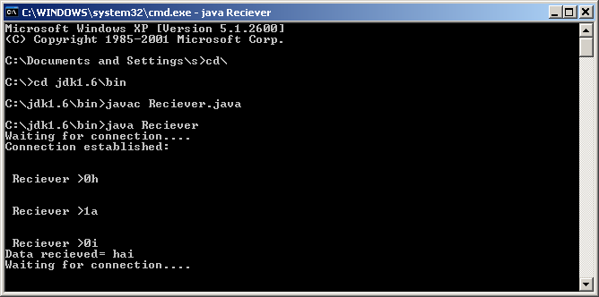

Ex No :07 Program To Implement Sliding Window Protocol

AIM:
Write a program to Implement Sliding Window Protocol
Sliding Window Protocol
Sliding window protocols are data link layer protocols for reliable and sequential delivery of data frames. The sliding window is also used in Transmission Control Protocol.In this protocol, multiple frames can be sent by a sender at a time before receiving an acknowledgment from the receiver. The term sliding window refers to the imaginary boxes to hold frames. Sliding window method is also known as windowing.
Procedure to run a Program
Step 1:Write a server and client programs on the notepad and save it with .java extension,
Step 2: Open two different Command Prompt.
Step 3:Set the directory in which the .java file is saved.
Step 4:Use the following command to compile the Java programs. It generates a .class file in the same folder. It also shows an error if any.
Javac filename.java
Step 5:Use the following command to run the Java program: java Filename, First execute the server program and then execute the client program and type the message in client side.

SOURCE CODE

Server:
import java.io.*;
import java.net.*;
class slisender
{
public static void main(String aafhbasgj[])throws Exception
{
ServerSocket ss=new ServerSocket(640);
Socket s=ss.accept();
BufferedReader br=new BufferedReader(new InputStreamReader(System.in));
DataInputStream in=new DataInputStream(s.getInputStream());
String str1;
System.out.println("Enter number of iterations:");
int it=Integer.parseInt(br.readLine());
int intr=0;
int msg[]=new int[8];
for(int i=0;i<8;i++)
msg[i]=i;
PrintStream p;
int no;
p=new PrintStream(s.getOutputStream());
p.println(it);
System.out.println("Enter window size:");
no=Integer.parseInt(br.readLine());
p.println(no);
int i=0;
while(intr<it)

{
p.println(msg[i]);
i++;
if(i==no)
{
str1=in.readLine();
System.out.println(str1);
}
if(i==8)
{
i=0;
intr++;
}
}
ss.close();
s.close();
}
}

Client:
import java.io.*;
import java.net.*;
class sliclient
{
public static void main(String aafhbasgj[])throws Exception
{
Socket s=new Socket("localhost",640);
String opmsg;
BufferedReader br=new BufferedReader(new InputStreamReader(System.in));
DataInputStream in=new DataInputStream(s.getInputStream());
PrintStream dos=new PrintStream(s.getOutputStream());
int iterations=Integer.parseInt(in.readLine());
String msg=in.readLine();
int no=Integer.parseInt(msg);
int i=0,intr=0,iframe=0;
int framecounter=0;
while(intr<iterations)
{
msg=in.readLine();
System.out.println(msg);
i++;
framecounter++;
if(framecounter%no==0)
{
System.out.println("Sending ack to server");
opmsg="ACK:FRAME"+iframe+"RECEIVED";
dos.println(opmsg);

iframe++;
}
if(i==8)
{
i=0;
intr++;
}
}
s.close();
}
}

OUTPUT:

Server:
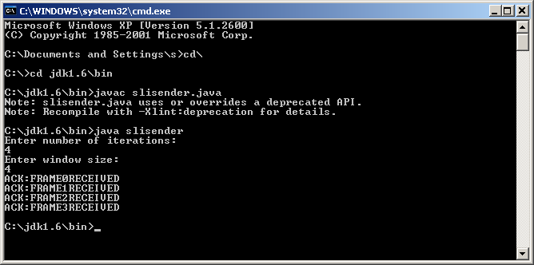

Client:

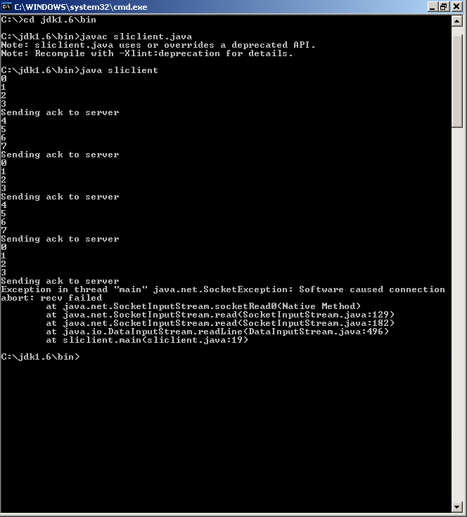

Ex No: 08 Program To Implement The Shortest Path Routing Using Dijkstra Algorithm

AIM:
Write a program to Implement The Shortest Path Routing Using Dijkstra Algorithm.
Dijkstra Algorithm
Dijkstra’s algorithm is very similar to Prim’s algorithm for minimum spanning tree. Like Prim’s MST, we generate a SPT (shortest path tree) with given source as root. We maintain two sets, one set contains vertices included in shortest path tree, other set includes vertices not yet included in shortest path tree. At every step of the algorithm, we find a vertex which is in the other set (set of not yet included) and has a minimum distance from the source.
Procedure to run a program

Step 1: Locate the TC.exe file and open it. You will find it at location C:\TC\BIN\.
Step 2: File > New (as shown in above picture) and then write your C program
Step 3: Save the program using F2 (OR file > Save), the extension should be “.c”.
Step 4: Compile the program using Alt + F9 OR Compile > Compile
Step 5: Press Ctrl + F9 to Run (or select Run > Run in menu bar ) the C program.
Step 6: Alt+F5 to view the output of the program at the output screen.

SOURCE CODE :
# include<stdio.h>
# include<conio.h>
#define Infinity 999
void dij(int n,int v,int cost[10][10],int dist[])
{
int i,u,count,w,flag[10],min;
for(i=0;i<=n;i++)
flag[i]=0,dist[i]=cost[v][i];
count=2;
while(count<=n)
{
min=99;
for(w=1;w<=n;w++)
if(dist[w]<min && !flag[w])
min=dist[w],u=w;
flag[u]=1;
count++;
for(w=1;w<=n;w++)
if((dist[u]+cost[u][w]<dist[w]) && !flag[w])

dist[w]=dist[u]+cost[u][w];
}
}
void main()
{
int n,v,i,j,cost[10][10],dist[10];
clrscr();
printf("\n Enter the numbeer of nodes:");
scanf("%d",&n);
printf("\n Enter the cost of matrix:\n");
for(i=1;i<=n;i++)
for(j=1;j<=n;j++)
{
scanf("%d", &cost[i][j]);
if(cost[i][j]==0)
cost[i][j]=Infinity;
}
printf("\n Enter the source matrix:");
scanf("%d",&v);
dij(n,v,cost,dist);
printf("\n Shortest path:\n");
for(i=1;i<=n;i++)
if(i!=v)
printf("%d->%d,cost=%d\n",v,i,dist[i]);
getch();
}

OUTPUT:
Shortest Path Algorithm DIJKSTRA's ALGORITHM

Enter the weight of the path between node 1 and 2:12
Enter the weight of the path between node 1 and 3:13
Enter the weight of the path between node 1 and 4:2
Enter the weight of the path between node 1 and 5:3

Enter the weight of the path between node 2 and 3:3
Enter the weight of the path between node 2 and 4:7
Enter the weight of the path between node 2 and 5:10

Enter the weight of the path between node 3 and 4:14
Enter the weight of the path between node 3 and 5:2

Enter the weight of the path between node 4 and 5:10

Enter the source:1

Enter the target:2
AECB
Shortest path:8

Ex No :09 Socket Program to Perform file transfer from Server to the Client
Date :
AIM:
Socket Program to Perform file transfer from Server to the Client.
File transfer from Server to the Client
A File Transfer Protocol client (FTP client) is a software utility that establishes a connection between a host computer and a remote server, typically an FTP server. An FTP client provides the dual-direction transfer of data and files between two computers over a TCP network or an Internet connection.
Procedure to run a Program
Step 1:Write a server and client programs on the notepad and save it with .java extension,
Step 2: Open two different Command Prompt.
Step 3:Set the directory in which the .java file is saved.
Step 4:Use the following command to compile the Java programs. It generates a .class file in the same folder. It also shows an error if any.
Javac filename.java
Step 5:Use the following command to run the Java program: java Filename, First execute the server program and then execute the client program and type the file name to be transferred in client side.

SOURCE CODE

Server:
import java.io.*;
import java.net.*;
import java.util.*;
public class FileServer
{
public static void main(String args[])throws IOException
{
ServerSocket ss=null;
try
{
ss=new ServerSocket(8081);
}
catch(IOException e)
{
System.out.println("couldn't listen");
System.exit(0);
}
Socket cs=null;
try
{
cs=ss.accept();
System.out.println("connection established"+cs);
}
catch(Exception e)
{

System.out.println("accept failed");
System.exit(1);
}
PrintWriter put=new PrintWriter(cs.getOutputStream(),true);
BufferedReader st=new BufferedReader(new InputStreamReader(cs.getInputStream()));
String s=st.readLine();
System.out.println("the requested file is:"+s);
File f=new File(s);
if(f.exists())
{
BufferedInputStream d=new BufferedInputStream(new FileInputStream(s));
BufferedOutputStream outStream=new BufferedOutputStream(cs.getOutputStream());
byte buffer[]=new byte[1024];
int read;
while((read=d.read(buffer))!=-1)
{
outStream.write(buffer,0,read);
outStream.flush();
}
d.close();
System.out.println("file transfered");
cs.close();
ss.close();
}
}
}

Client:-
import java.io.*;
import java.net.*;
import java.util.*;
class FileClient
{
public static void main(String args[])throws IOException
{
Socket s=null;
BufferedReader get=null;
PrintWriter put=null;
try
{
s=new Socket("127.0.0.1",8081);
get=new BufferedReader(new InputStreamReader(s.getInputStream()));
put=new PrintWriter(s.getOutputStream(),true);
}
catch(Exception e)
{
System.exit(0);
}
InputStreamReader get2=new InputStreamReader(s.getInputStream());
String u,f;
System.out.println("enter the filename to transfer from server:");
DataInputStream dis=new DataInputStream(System.in);
f=dis.readLine();
put.println(f);
File f1=new File("c:\\output");
FileOutputStream fs=new FileOutputStream(f1);
BufferedInputStream d=new BufferedInputStream(s.getInputStream());
BufferedOutputStream outStream=new BufferedOutputStream(new FileOutputStream(f1));
byte buffer[]=new byte[1024];
int read;
while((read=d.read(buffer))!=-1)
{
outStream.write(buffer,0,read);
outStream.flush();
}
fs.close();
System.out.println("file received");
s.close();
}
}

OUTPUT :
Server:
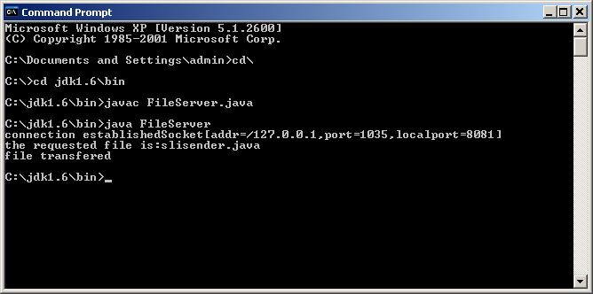

Reciever:

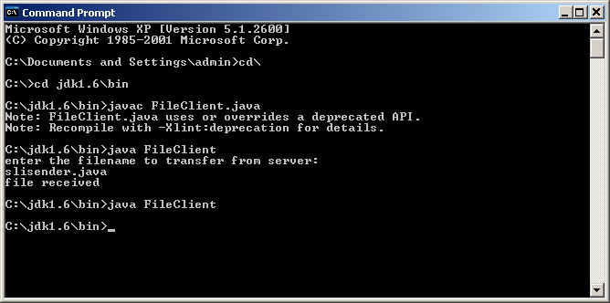

Ex No : 10 Program to implement Remote Procedure call under Client / Server
Environment

AIM:
Write a program to implement Remote Procedure call under Client / Server Environment

RPC

Remote Procedure Call (RPC) is a powerful technique for constructing distributed, client-server based applications. It is based on extending the conventional local procedure calling so that the called procedure need not exist in the same address space as the calling procedure. The two processes may be on the same system, or they may be on different systems with a network connecting them.

Procedure to run a Program
Step 1:Write a server,client,interface, interface implementation programs on the notepad and save it with .java extension,
Step 2: Open different Command Prompt.
Step 3:Set the directory in which the .java file is saved.
Step 4:Use the following command to compile all the Java programs. It generates a .class file in the same folder. It also shows an error if any.
Javac filename.java
Step 5:Use the following command to run the Java program: java Filename, start rmiregistry and then execute the server program and then execute the client program and type the value in client side.

SOURCE CODE:

//Remote method interface—FactIntf.java
import java.rmi.*;
public interface FactIntf extends Remote
{
long factorial(int n)throws RemoteException;
}

//Remote behavior implementation—FactImpl.java
import java.rmi.*;
import java.rmi.server.*;
public class FactImpl extends UnicastRemoteObject implements
FactIntf
{
public FactImpl()throws RemoteException {}
public long factorial(int n)throws RemoteException
{
long f=1;
for(int i=n;i>0;i--)
f*=i;
return f;
}
}

//Server that registers the service—FactServer.java
import java.rmi.*;
public class FactServer
{
public static void main(String args[])
{
try
{
FactIntf Fa=new FactImpl();
Naming.rebind("FactService",Fa);
}
catch(Exception e)
{
System.out.println(e.getMessage());
}
}
}

//Client that invokes remote host methods—FactClient.java
import java.rmi.*;
import java.net.*;
public class FactClient
{
public static void main(String args[])
{
try
{
FactIntf Fa=(FactIntf) Naming.lookup("rmi://"+args[0]+"/FactService");
if(args.length!=2)
{
System.out.println("Usage:java FactClient<remoteip><number>");
System.exit(-1);
}
int n=Integer.parseInt(args[1]);
long factval=Fa.factorial(n);
System.out.println("\n" + n+"Factorial value is:"+factval);
}
catch(Exception e)
{
System.out.println(e.getMessage());
}
}
}

OUTPUT :
Server:

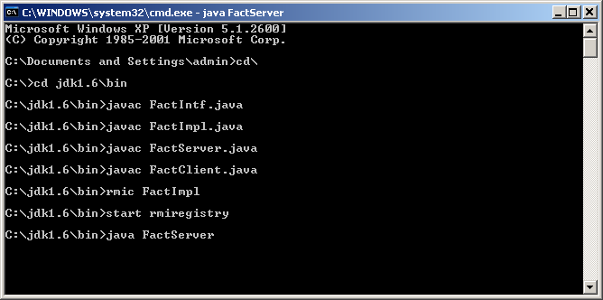

Client:

C:\>java FactClient localhost 5
5 Factorial value is 120

Enhancement 1: Program To Implement Simple Message Passing

AIM:
Write a Program to implement Simple Message Passing.

CLIENT
- Start the program
- Include necessary package in java
- To create a socket in client to server.
- The client establishes a connection to the server.
- The client accept the connection and to send the data from client to server.
- The client communicates the server to send the end of the message
- Stop the program.

SERVER
- Start the program
- Include necessary package in java
- To create a socket in server to client
- The server establishes a connection to the client.
- The server accept the connection and to send the data from server to client and
- vice versa
- The server communicate the client to send the end of the message.
- Stop the program.

PROGRAM

TCPserver1.java

import java.net.*; import java.io.*;

public class TCPserver1
{
public static void main(String arg[])
{
ServerSocket s=null; String line;
DataInputStream is=null,is1=null; PrintStream os=null;
Socket c=null; try
{
s=new ServerSocket(9999);
}
catch(IOException e)
{
System.out.println(e);
} try
{
c=s.accept();
is=new DataInputStream(c.getInputStream()); is1=new DataInputStream(System.in); os=new PrintStream(c.getOutputStream()); do
{
line=is.readLine(); System.out.println("Client:"+line); System.out.println("Server:"); line=is1.readLine(); os.println(line);
}
while(line.equalsIgnoreCase("quit")==false); is.close();
os.close();
}
catch(IOException e)
{
System.out.println(e);
}
}
}

TCPclient1.java

import java.net.*; import java.io.*;

public class TCPclient1
{
public static void main(String arg[])
{
Socket c=null; String line;
DataInputStream is,is1; PrintStream os;
try
{
c=new Socket("10.0.200.36",9999);
}
catch(IOException e)
{
System.out.println(e);
}
try
{
os=new PrintStream(c.getOutputStream()); is=new DataInputStream(System.in);
is1=new DataInputStream(c.getInputStream()); do
{
System.out.println("Client:"); line=is.readLine(); os.println(line);
System.out.println("Server:" + is1.readLine());
}
while(line.equalsIgnoreCase("quit")==false); is1.close();
os.close();
}
catch(IOException e)
{
System.out.println("Socket Closed!Message Passing is over");
}}

OUTPUT :

SERVER

C:\Program Files\Java\jdk1.5.0\bin>javac TCPserver1.java
Note: TCPserver1.java uses or overrides a deprecated API.
Note: Recompile with -deprecation for details. C:\Program Files\Java\jdk1.5.0\bin>java TCPserver1

Client: Hai Server Server:Hai Client Client: How are you Server:Fine
Client: quit Server:quit

CLIENT

C:\Program Files\Java\jdk1.5.0\bin>javac TCPclient1.java
Note: TCPclient1.java uses or overrides a deprecated API. Note: Recompile with -deprecation for details.
C:\Program Files\Java\jdk1.5.0\bin>java TCPclient1

Client:Hai Server Server: Hai Client Client:How are you Server: Fine Client:quit
Server: quit

Enhancement 2: Program To Implement Remote Command Execution

AIM:
Write a program to Implement Remote command execution

ALGORITHM
CLIENT SIDE
1.Establish a connection between the Client and Server. Socket client=new Socket("127.0.0.1",6555);
2.Create instances for input and output streams.
Print Stream ps=new Print Stream(client.getOutputStream());
3.BufferedReader br=new BufferedReader(newInputStreamReader(System.in));
4.Enter the command in Client Window. Send the message to its output str=br.readLine();
ps.println(str);
SERVER SIDE
1.Accept the connection request by the client. ServerSocket server=new ServerSocket(6555); Socket s=server.accept();
2.Get the IPaddress from its inputstream.
BufferedReader br1=new BufferedReader(newInputStreamReader(s.getInputStream())); ip=br1.readLine();
3.During runtime execute the process Runtime r=Runtime.getRuntime(); Process p=r.exec(str);

CLIENT PROGRAM
import java.io.*; import java.net.*;
class clientRCE
{
public static void main(String args[]) throws IOException
{
try
{
String str;Socket client=new Socket("127.0.0.1",6555);
PrintStream ps=new PrintStream(client.getOutputStream());
BufferedReader br=new BufferedReader(newInputStreamReader(System.in)); System.out.println("\t\t\t\tCLIENT WINDOW\n\n\t\tEnter TheCommand:"); str=br.readLine();
ps.println(str);

}
catch(IOException e)
{
System.out.println("Error"+e); }}}
SERVER PROGRAM:
import java.io.*; import java.net.*;
class serverRCE
{
public static void main(String args[]) throws IOException
{
try
{
String str;
ServerSocket server=new ServerSocket(6555); Socket s=server.accept();

BufferedReader br=new BufferedReader(newInputStreamReader(s.getInputStream())); str=br.readLine();
Runtime r=Runtime.getRuntime(); Process p=r.exec(str);
}
catch(IOException e)
{
System.out.println("Error"+e);
}
}}
OUTPUT
C:\Networking Programs>java serverRCE
C:\Networking Programs>java clientRCE
CLIENT WINDOW
Enter The Command:
Notepad

